

COURSE NAME: Algorithm Analysis

STUDENT: Ertuğrul ŞENTÜRK

HOMEWORK SUBJECT: Backtracking

Algorithm:

1. A predefined color set has been printed.
2. Information was received from the user whether he wanted matrix size, color matrix and processing steps.
3. While importing the matrix, the index of the elements in the color array was recorded in the matrix. If the entered element is not in the color array, the program is terminated.
4. Backtracking function is called. This function is calculated starting from the first row.
5. Each row that was processed was compared with the lines above it and it was checked whether there is an element in the same column that is the same as the elements in the row.
6. If all elements are different, the function is called for the next row.
7. In case we passed the bottom row, the function returned true.
8. If one of the elements in the row is the same, the process is repeated by rotating as many rows as the number of elements in the row.
9. Every time the rotation is done, if the user has requested the operation steps, an output is given.
10. If as many rows are made in the top row, the result is returned false.
11. An output is given to the user, depending on whether the result is true or false.

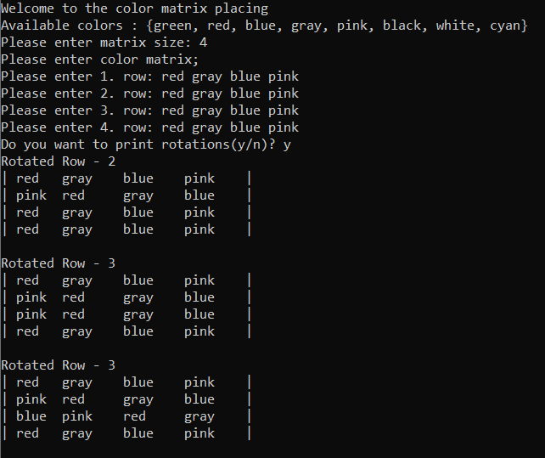 Screenshots:

